  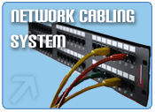
  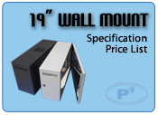
  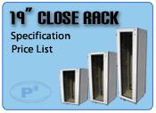
  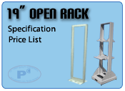
  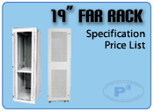
  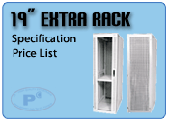
  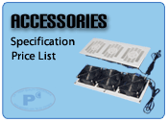
  19" High Quality Export Rack  19" High Quality Export Rack Design and product Modular knock down system. Which is very easy to assemble remove the rack.  Material made of electro galvanized sheet steel 1.5mm.thickness.Mounting Pole, Frame Structure and Base made of 2.0mm. Caster stand made of 3.0mm. steel 100% rust-proof and durable.  The roof of rack can be install ventilating fan 1 ea. to 6 ea. Maximum (1x4", 2x4", 3x4"). It is transferred to be vented raised roof cover (Option). Slide shutter for cable can additional (Option). | 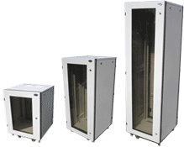
  The inside of rack can be built the PL.7w. light and limit switch for automation lighting on-off when open and close rear door (Option).
  The front door is brown color transparency plastic acrylic 5mm. thickness for lightweight, can be change opened the door with right or left handle. The seal on the edge to prevent dust. Security Locks is turn lock.
  The rear door has two key locked (27U up) and perforated ventilation with dust-proof filter, can be change opened the door with right or left handle. The seal on the edge to prevent dust. Security Locks is push lock.
  The bottom rack have slide shutter for cable and protection intrusion of animal. Ventilation fan can additional (Option).
  The side panel security with security lock is turn lock can be quick release for install or maintenance.
  Mounting vertical frames support is electro galvanized sheet steel 2mm. thickness, can be adjustment as requirement Square mounting holes in compliance with IEC297, DIN with extraordinary strength.
  The hinged of front-rear door made from aluminum for heavy duty (Hardness and 100% rust-proof finish).
  The rack include 4 adjustable level stand for easy install and 4 castors wheel for easy remove. Caster made of white Nylon Six with equipped on the 360 degree swivel that allow to be moving conveniently with capacity the static load 100 Kg./caster.
  Ground system all part of rack completed by cable earth kit.
  Provide with M6 bolt cage nuts and plastic washers.
  Finish coat is Two-Tone with gray and back gray made of powder epoxy coating by electro-static system for drying to enhance strength.
  Meet to with standard ANIS/EIA-310D-1992 (Rev.EIA-310-C), IEC 60297-1, IEC 60297-2, BS 5954:Part 2, DIN 41494.
  Manufacturing standard ISO 9001: 2000 Company.
  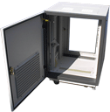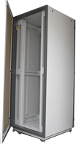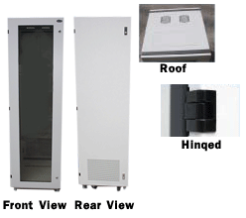
  U  1U=44.45mm. | Height (mm.) | Order NO. (Width* x Depth*:mm.)
  U  1U=44.45mm. | H | 600x600 | 600x800 | 600x900 | 600x1000 | 600x1100
  15U | 850 | PM-6615 | PM-6815 | - | - | -
  27U | 1390 | PM-6627 | PM-6827 | PM-6927 | PM-6027 | -
  36U | 1790 | PM-6636 | PM-6836 | PM-6936 | PM-6036 | -
  39U | 1921 | PM-6639 | PM-6839 | PM-6939 | PM-6039 | -
  42U | 2050 | PM-6642 | PM-6842 | PM-6942 | PM-6042 | PM-6142
  45U | 2185 | PM-6645 | PM-6845 | PM-6945 | PM-6045 | PM-6145
  *Width=800mm. Please Contract Distribution
  *Depth not include Front door and Rear door

